Tab 1

### **Adding Events on Strapi**

#### **1. Log in to your account:**

[Strapi Admin Dashboard](https://prod-strapi.jkyog.org/admin/content-manager/collectionType/api::appevent.appevent?page=1&pageSize=10&sort=EventTitle:ASC)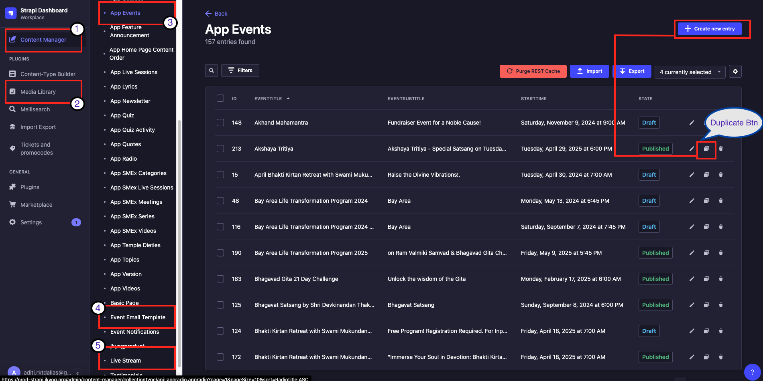

### **Strapi Sections and Their Purpose**

1. **Content Manager** → Create **New Events, Emails, and Sevas**.
2. **Media Library** → Upload and manage **event images**.
3. **App Events** → Add and manage **events**.
4. **Event Email Templates** → Set up **registration emails**.
5. **Live Streams** → Create and add **Sevas**.

#### **Uploading Event Images**

#### 

* Navigate to the **Media Library**.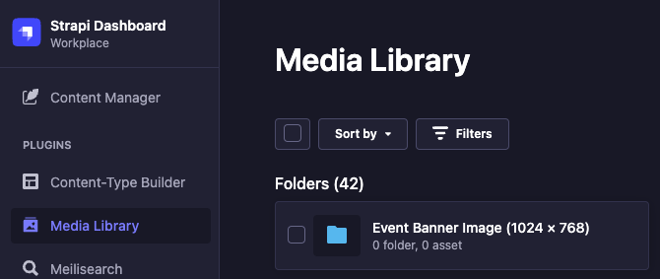
* Open the **Event Banner Images (1024 x 768)** folder.
* Click **Add New Assets** in the top-right corner.
* Browse and upload the desired image from your device.
* After uploading, click on the image and select the **chain link** icon to copy the image URL. *(Save this URL for later use in the event creation.)*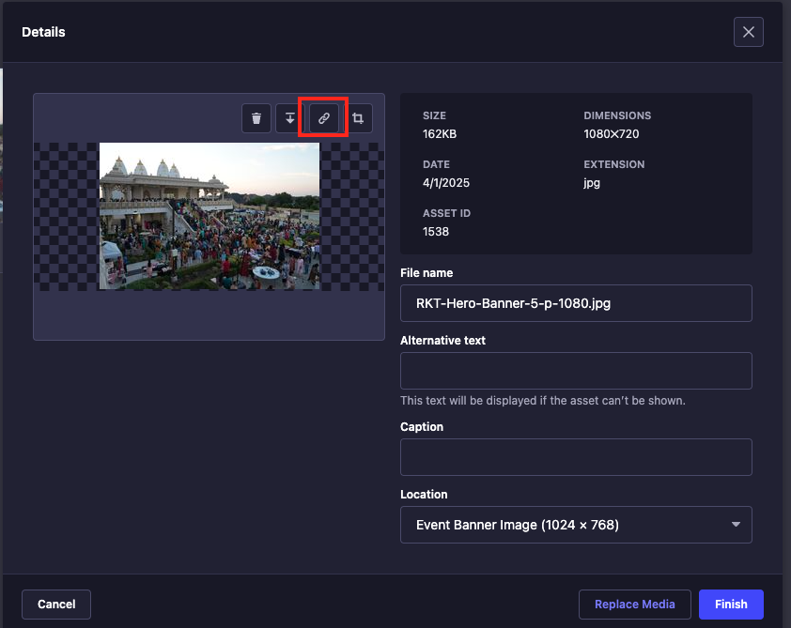

#### **Creating an Event**

#### 

* Ensure you are in the **Content Manager** tab.
* Select **App Events** from the content menu.
* Choose **Create New Entry** or **Duplicate** an existing event.
* Fill in all required fields, including:
  + **Banner Image URL** (from the Media Library).
  + **Email & Phone Contact:** secretary@jkyog.org or call **(469) 795-9130**.
  + **brevocontactlistname:** /rkt-[eventname].
  + **EventURLSlug:** [eventname] (Check the provided screenshot for reference).
  + **UUID:** *(Copy this as it is required for registration.)*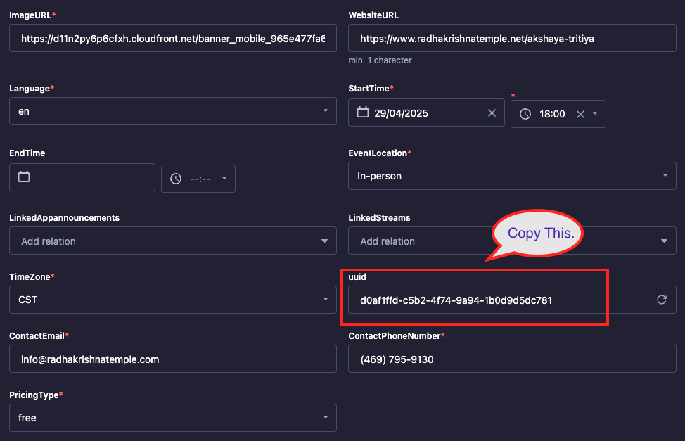
  + **isEvent:** Set to **false**.
  + **EventType:** Select **General**.
  + **EventPlatform:** Choose **RKT** from the dropdown.
* **Before publishing:**
  + Save your work.
  + If duplicating an event, remove the existing email template:
    - Select **Email Template** and remove the previous one. *(This is for registration emails.)*
  + Create a **Live Stream** for the event: *(Before clicking on the Live Stream or Email Template tab, save your work.)*
    - Select the **particular event's** live stream. *(This is for seva or sponsorship options.)*
* Click **Save and Publish**.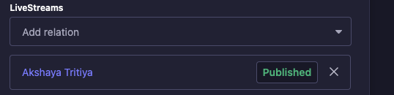

## **Adding Highlights**

1. In the **App Event**, scroll to the content section.
2. Click **Add a Component** → Select selectTab.



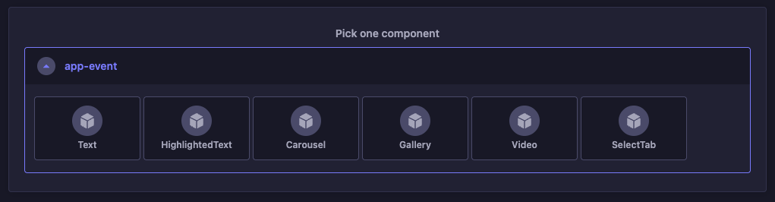

1. In the **title**, enter: Highlights.

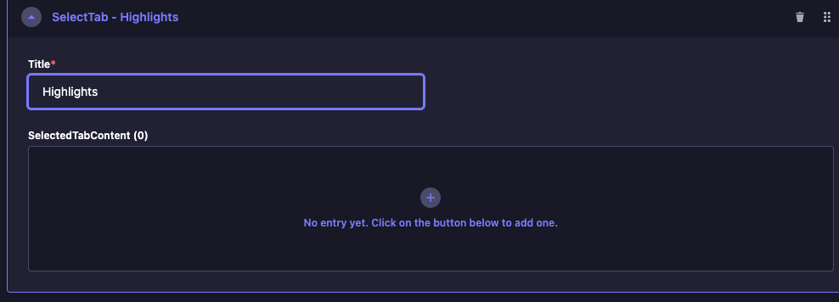

### **To Add Highlights:**

* Click the **+ (plus)** icon inside Highlights.
* Add:
  + **Title** of the highlight.
  + **Image**.
  + **Description**.
  + Click **Save**.  
      
    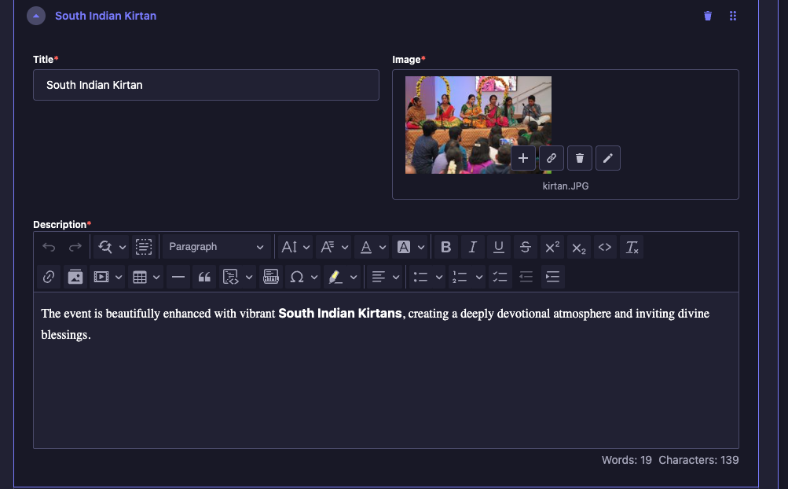

## **Adding Gallery**

1. In the same content section, click **Add a Component**.



1. Choose Gallery.

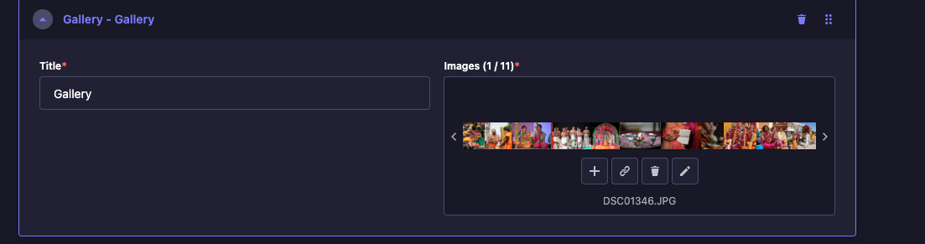

### **To Add Gallery Items:**

* Enter the **title** (e.g., "Gallery").
* Upload **images** as needed.
* Click **Save** and then **Publish**.

#### **Creating an Email Template**

* Use an **existing template** or **create a new one**.
* Modify the **subject** as needed.
* Update the **template** and link it to the event. *(Or go to the App Event for that particular event and add it there.)*
* Click **Save and Publish**.

#### **Creating a Live Stream**

#### 

* Navigate to the **Live Streams** tab.
* Click **Create New Entry** *(or duplicate an existing one if the sevas match, but creating a new entry is recommended)*.
* **Add Title** for the event.
* Scroll down and click on **Event Sevas**.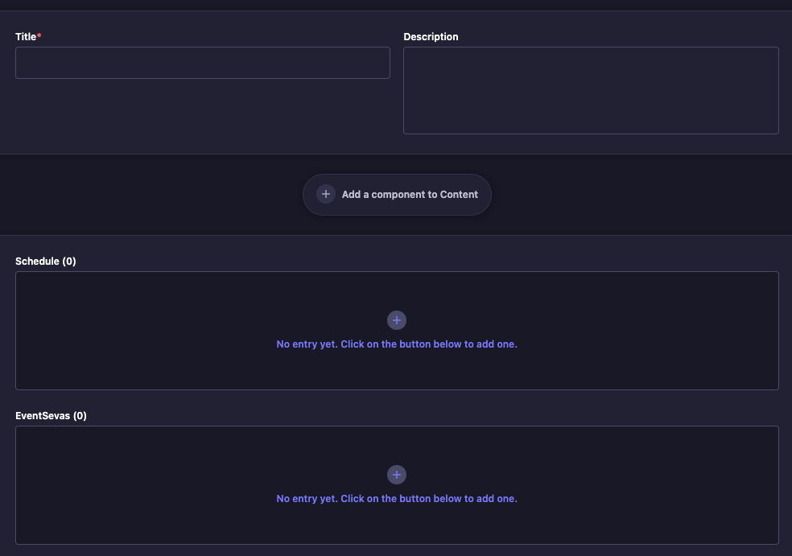
* For each seva:
  + In **Title**, enter the seva name (e.g., *Grand Sponsor*).
  + In **Price**, enter the seva price.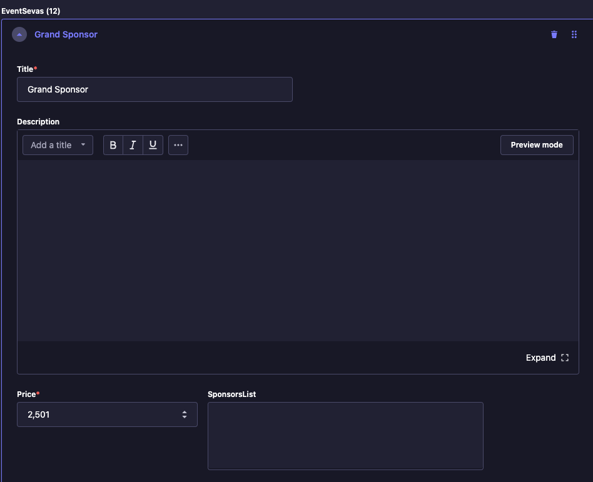
* Continue adding sevas as needed.
* **Link the live stream to the event**, or go to the event and add it from there.
* Click **Save and Publish**.

## **Adding Schedule for Recurring Events or Multi-Day Timelines**

To manage events that span **multiple days** or have **multiple time slots**, use the **Schedule** option within the **Live Streams** section.

### **Steps:**

1. Navigate to **Content Manager → Live Streams**.
2. Select the **event’s live stream entry** where you have added Sevas.
3. Scroll to find the **Schedule** section.
4. Click  **Add New Entry** under **Schedule**.

### **Required Fields to Fill:**

* **Title**: e.g., "Opening Ceremony", "Satsang Day 1", "Day 2 – Gita Chanting"
* **Start Date & Time**
* **End Date & Time**
* **Location**
* **Description**
* **Sevas (if recurring event, can skip EventSevas)**
* After entering all schedule items:
  + Click **Save**.
  + Then **Publish** the Live Stream entry.

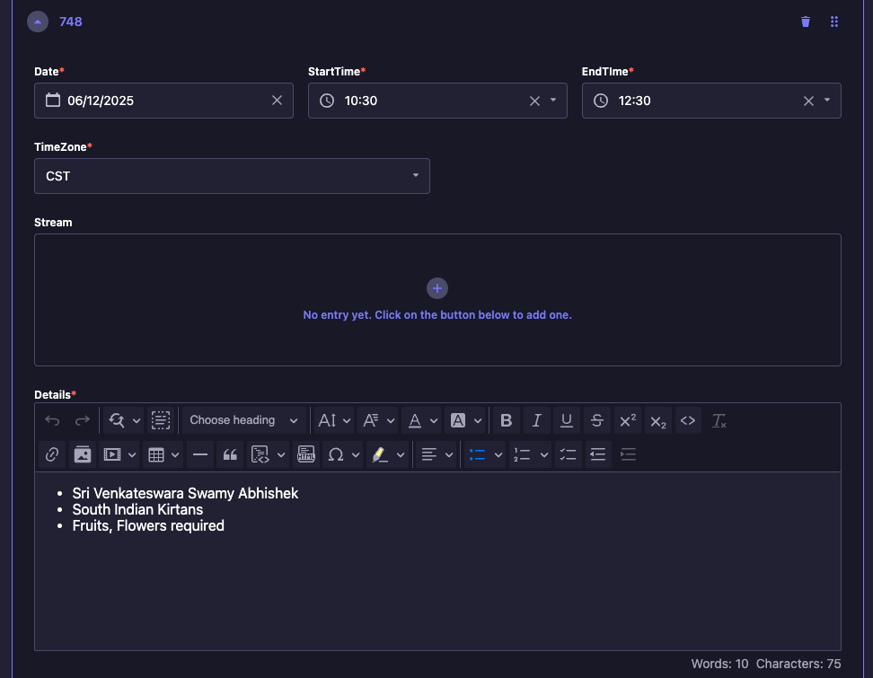

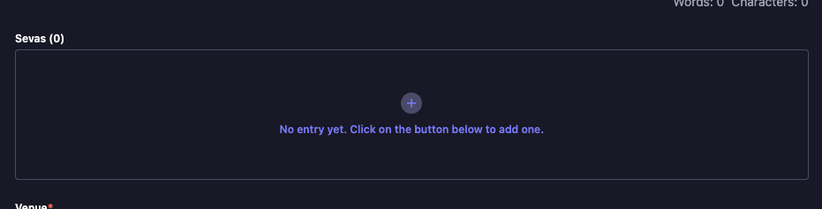

**Making Registration Work on Webflow**

### 

1. **Copy the Event Registration Component**
   * Use a previously working event registration form from events like *Ram Navami, Hanuman Jayanti, Holika Dahan, or Gujarati Bhajan Sandhya*. *(Refer to the provided screenshot for reference.)*

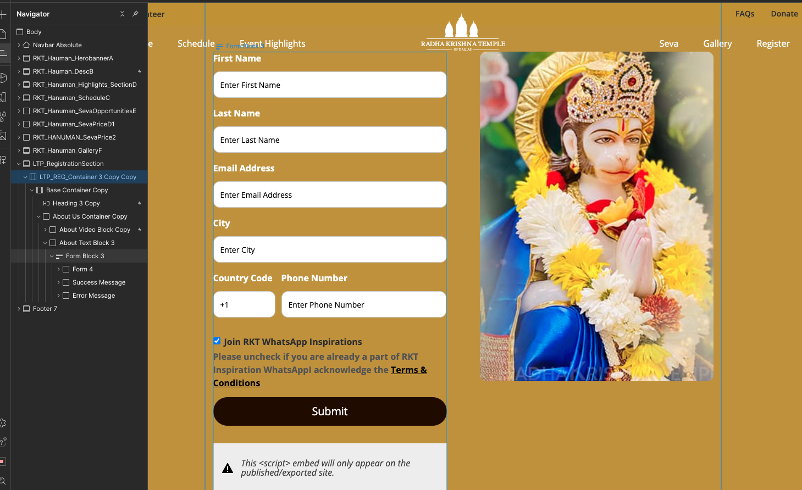

1. **Paste the Component**
   * Insert it into your event page.
2. **Verify Input Field IDs**
   * Ensure the pasted form has the correct input field IDs:
     + firstName
     + lastName
     + email
     + city
     + countryCode
     + phone
     + joinwhatsapp (checkbox)

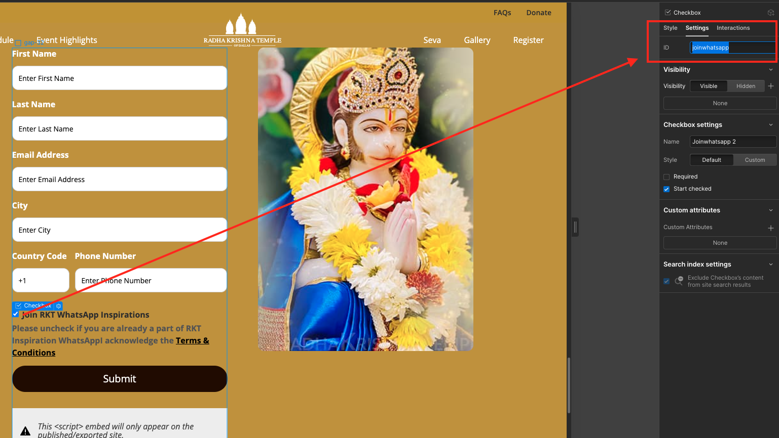

1. **Edit the Embedded Code**
   * Double-click on the **code embed** element inside Webflow.
2. **Update the eventUuid**
   * Locate **line 25** in the embedded code.
   * Replace the existing eventUuid with the correct one from **Strapi App Event**.

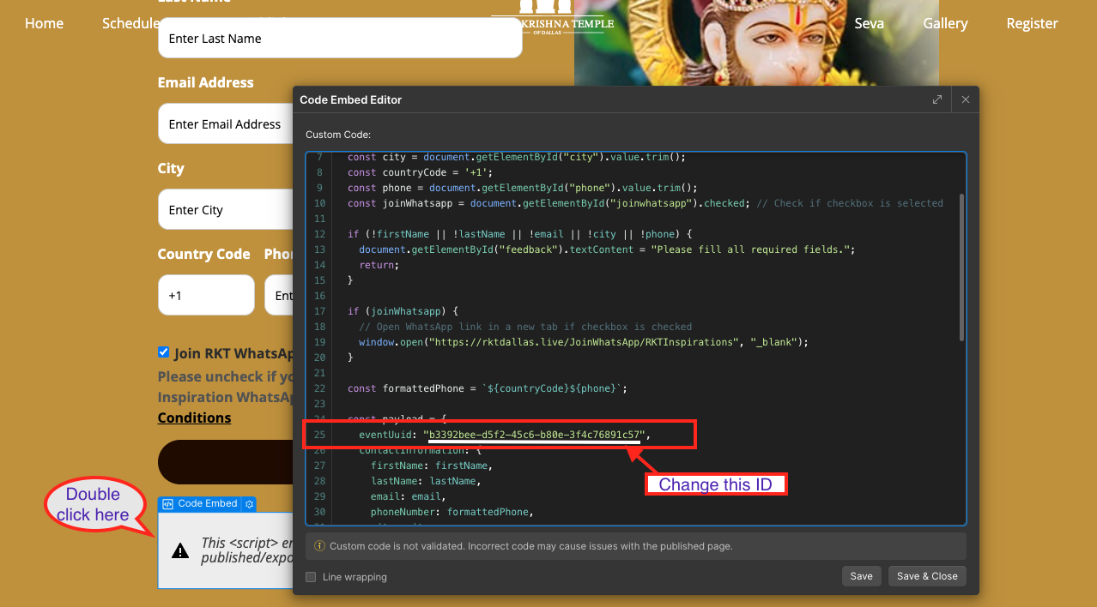

1. **Save and Close**
   * Click **Save and Close** after making changes.
2. **Publish the Changes**
   * Click **Publish** to make the registration live.

Payment Tickets

**Add Tickets & Promocodes for some of the pages:**

Ex: Retreats, we will use the below procedure to add the payment details which in turn navigates the payments successfully in the form.   
  
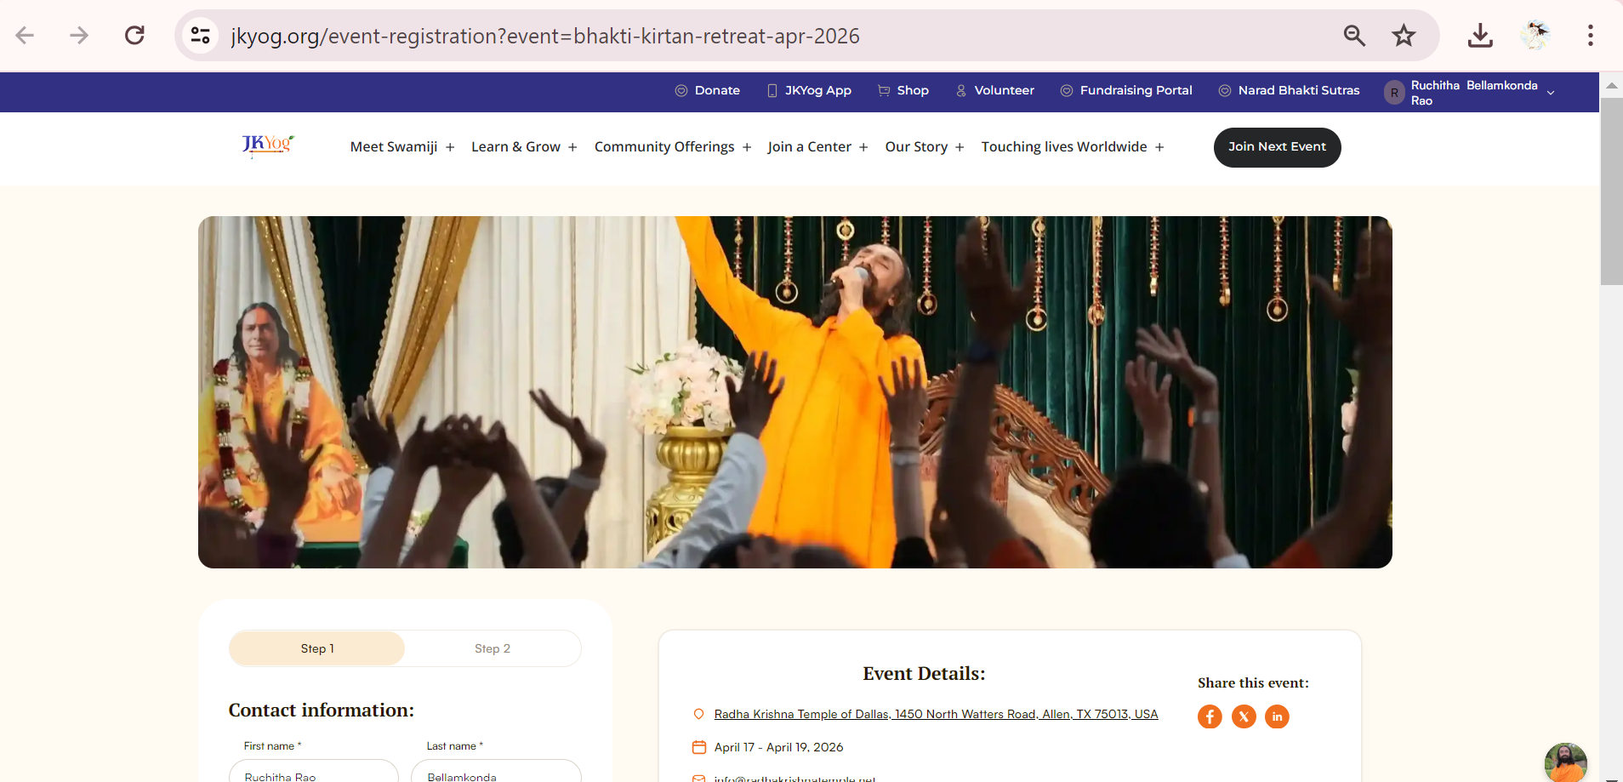  
  
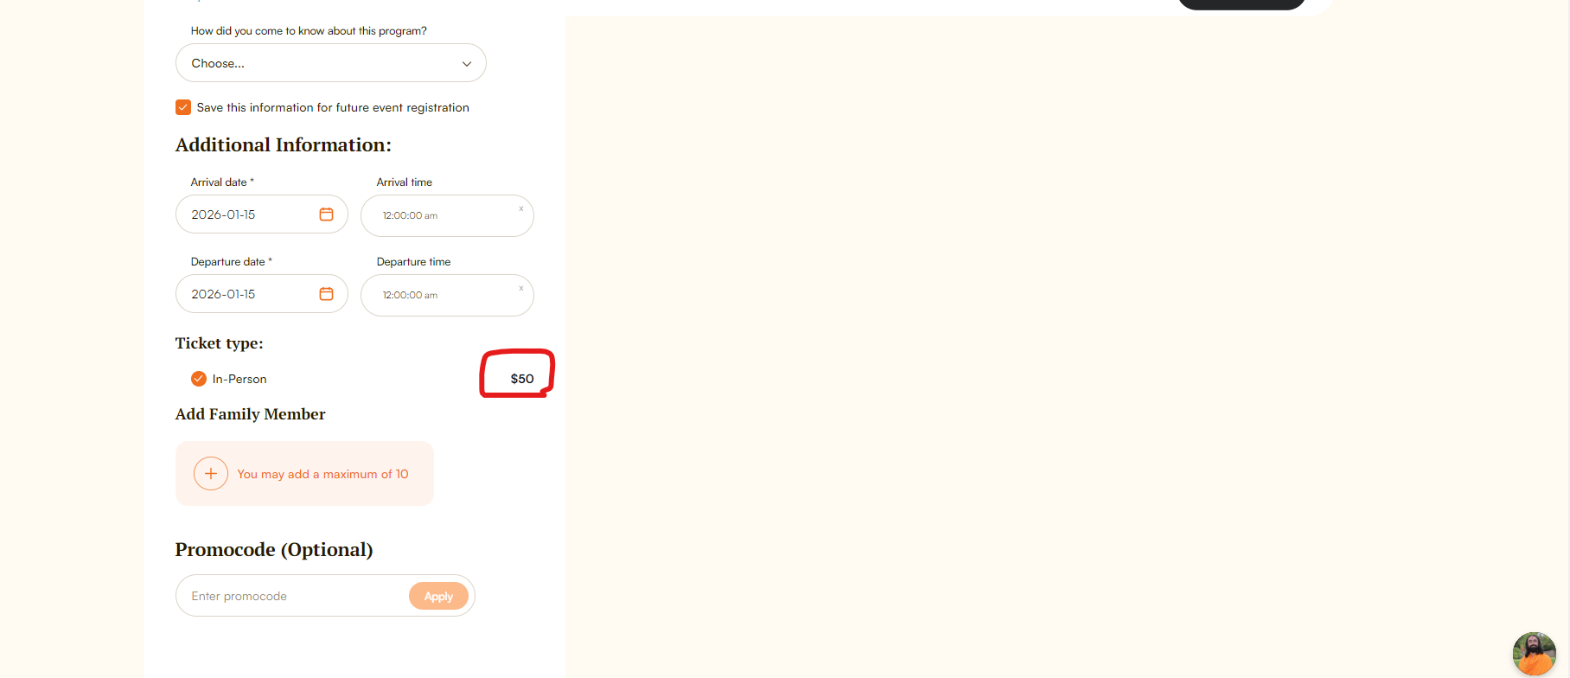  
  
If the below steps are not completed, The highlighted amount shows as $0  
  
Kindly make sure the ticket has been created for it.  
  
**Steps to be followed:**  
  
1. In strapie look for Tickets and promocode of the left panel.

2. Search for the related website/page name.

3. Add quantity, buy clicking on show.  
  
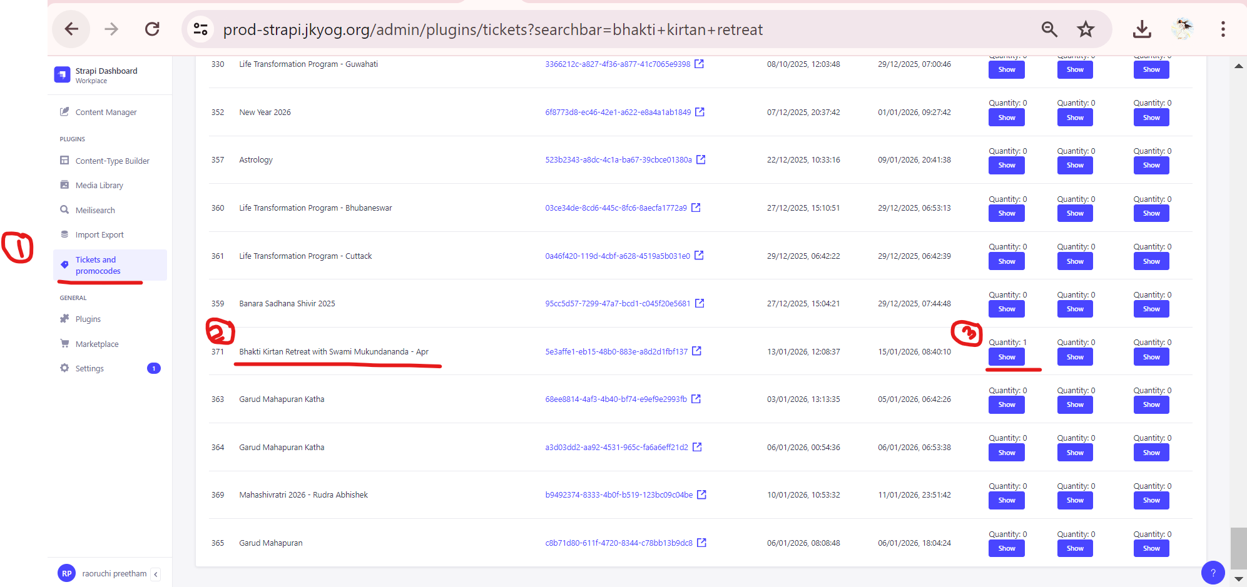

4. Add ticket & enter the details.

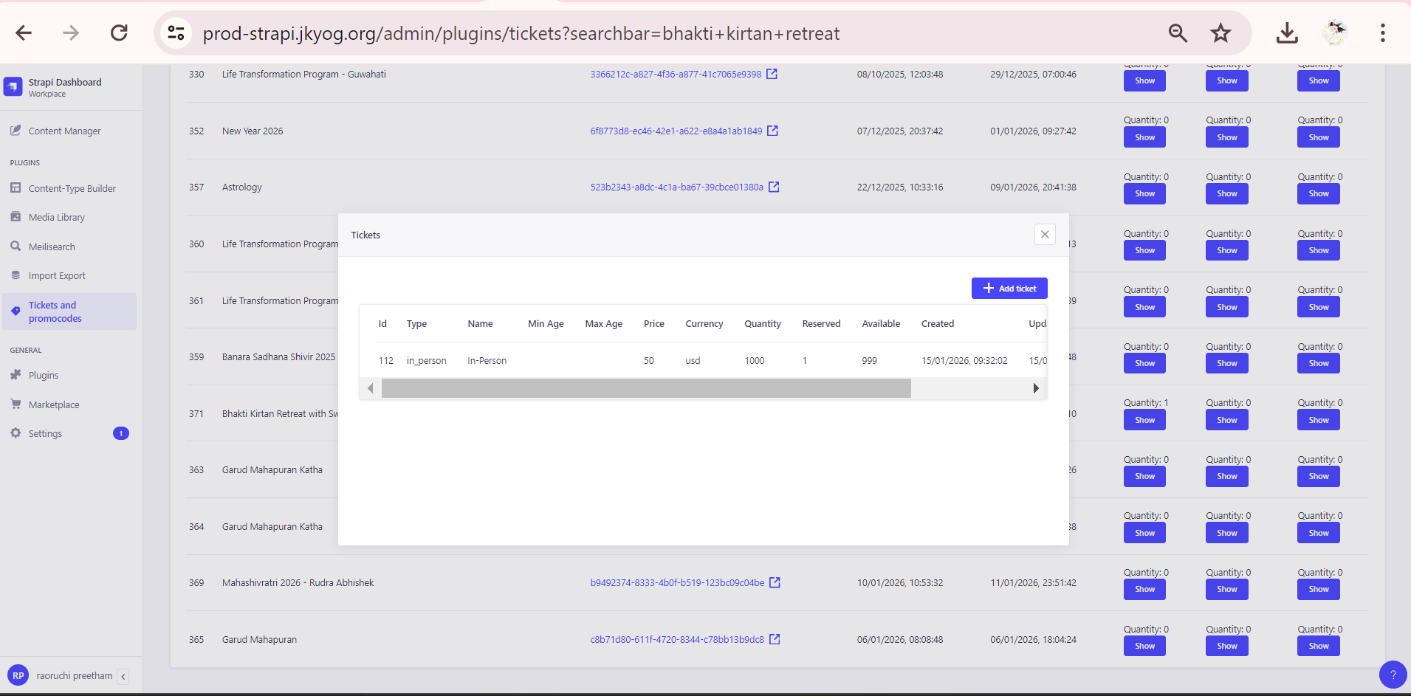  
  
**Webflow minor steps to follow: (Bhakti Kirtan Retreat Page)**  
  
Unlike the usual way, for the **bhakti kirtan retreat** page registration, seva opportunities, watch live page has been done in a slightly different way.  
  
There is no registration section in the webflow page, rather we directly assign the web url to link buttons.   
  
Maintain a web url similar to slug provided.  
  
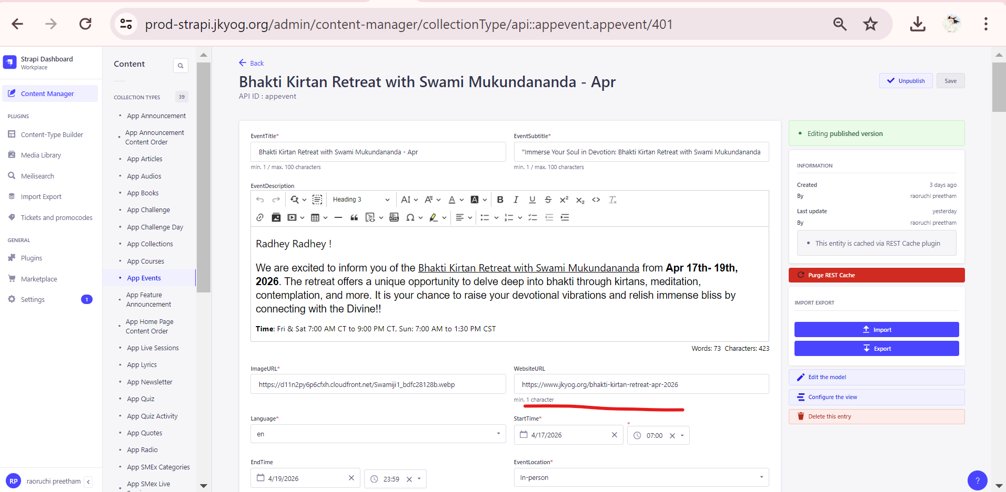  
  
Watch live button redirects to a page embedded from below strapie event under live stream.  
  
